Project
  - Phase1 - Deadline: Sunday 26/07/2026 @ 23:59 Phase2 – Deadline: Sunday 09/08/2026 @ 23:59
[Total Mark is 20]

Web Programming
IT361

Student Details: CRN:
Name:  Name:  Name:  Name: |  | ID:  ID:  ID:  ID:

Instructions:
- You must submit two separate copies (one Word file and one PDF file) using the Assignment Template on Blackboard via the allocated folder. These files must not be in compressed format.
- It is your responsibility to check and make sure that you have uploaded both the correct files.
- Zero mark will be given if you try to bypass the SafeAssign (e.g. misspell words, remove spaces between words, hide characters, use different character sets, convert text into image or languages other than English or any kind of manipulation).
- Email submission will not be accepted.
- You are advised to make your work clear and well-presented. This includes filling your information on the cover page.
- You must use this template, failing which will result in zero mark.
- You MUST show all your work, and text must not be converted into an image, unless specified otherwise by the question.
- Late submission will result in ZERO mark.
- The work should be your own, copying from students or other resources will result in ZERO mark.
- Use Times New Roman font for all your answers.

Description and Instructions
Learning Outcome (1, 2,3, 5,6):
Describe methods and tools in web development.
Create web pages using HTML5 and CSS3.
Develop dynamic web pages using JavaScript.
Create Rich Internet Applications.
Build web applications using PHP and MySQL.

Project Idea: “Campus Events Hub”
Each group will design and build a small dynamic website for a fictional university club or department that publishes upcoming campus events (workshops, seminars, competitions, trips) and lets students register for them online. The site is built with HTML and CSS for the front end, and basic PHP for the dynamic parts (page templates, form handling, validation, and saving registrations).
Group size: 3–4 students. Duration: 6 weeks.

Functional Requirements (Minimum)
The website must contain at least the following pages:
- Home page: introduction to the club/department and highlights of the next 3 upcoming events.
- Events page: a list of all events, generated by PHP from a data source (PHP array, text/CSV file, or a simple database table — the group chooses).
- Event details page: one page that displays the details of a selected event (using a GET parameter, e.g. event.php?id=3).
- Registration page: an HTML form (name, student ID, email, selected event) processed by PHP with server-side validation; valid registrations are appended to a text/CSV file or database table, and a confirmation message is shown.
- Registrations list page: a page that reads the stored registrations and displays them in an HTML table.
- About / Contact page: team members and a simple contact form (validation only; no email sending required).

Technical Requirements

HTML
- Valid, semantic markup (header, nav, main, section, footer); correct use of headings, lists, tables, images, and links.
- At least one data table and at least two forms with appropriate input types and labels.

CSS
- One shared external stylesheet (no inline styles except where justified).
- A consistent color scheme and typography, a styled navigation bar, and hover/focus states.
- A basic responsive behavior (e.g., layout adapts on small screens using media queries or flexible units).

PHP
- Shared header and footer using include/require on every page.
- Handling of GET and POST data with server-side validation (required fields, email format, etc.) and clear error messages.
- Reading and writing data (text/CSV file or a simple database table) and displaying it with loops.
- Code is organized, indented, and commented; no frameworks or site builders are allowed.
Timeline
- Week 1: team formation, choosing the club theme, sitemap and page sketches.
- Weeks 2–3: static HTML/CSS version of all pages.
- Week 3 (end): submit the mid-project progress report.
- Weeks 4–5: PHP work: templates, forms, validation, data storage and display.
- Week 6: testing, polishing, final report, and submission.

Submission Guidelines and Instructions

1. Mid-Project Progress Report
Each group must submit a short progress report at the end of Week 3, which must include:
- Work completed this period.
- One key decision made during this period.
- One problem encountered.
- Plan for the next period.
- Each group member's input/participation.

2. Weekly Progress Log (Inside the Submission File)
Students must document their progress inside the final submission file itself, in a dedicated section named “Progress Log”. The log must contain one dated entry per week (minimum 5 entries) written at the time of the work, not at the end. Each weekly entry must include:
- Date and week number.
- What was accomplished that week (2–4 sentences).
- Which member did what.
- At least one screenshot of the website or code as it looked that week (screenshots must show a visible date/timestamp, e.g., the system clock or file properties).
What NOT to do: Students must not build the entire project at the last minute and then write the log retroactively. Entries that all look written in one sitting, screenshots without dates, or a log that does not match the final work are treated as red flags regardless of the quality of the final website.

3. Project Artifacts
A separate section in the final report must be named “Project Artifacts” and must include:
- The full source code of the website as a ZIP file (all .html, .css, .php files, images, and any data files), submitted together with the report.
- A short “How to run” note (e.g., which folder to place in XAMPP/htdocs and which page to open first).
- The Progress Log section described above, with its screenshots.

4. Written Reflection (End-of-Project Report)
The final report must end with a Reflection section (300–500 words), written in the students' own words, addressing some of the following:
- Describe one specific challenge or obstacle you encountered during this project and explain in detail how you identified and resolved it.
- Explain why you chose your specific approach (e.g., CSV file vs. database, page layout technique) over at least one alternative you considered, and what tradeoffs informed that decision.
- If you used any AI tools during this project (e.g., ChatGPT, Claude, Copilot), disclose which tool(s), for what specific purpose (e.g., debugging, grammar checking, brainstorming), and how you verified or modified the output.
- What would you do differently if you were to redo this project with more time or resources?
This section will be evaluated for specificity and consistency with the technical content of the project report.
Important Notes
- AI use: Students may use AI tools (ChatGPT, Claude, Copilot, Gemini, etc.) only for brainstorming approaches, debugging small errors, or proofreading text. AI must not be used to generate the code logic or produce substantial portions of the report or website. Any permitted AI use must be disclosed in the Reflection section. Undisclosed AI use, or AI use beyond this scope (disclosed or not), will result in a zero grade for the entire project.
- Any submission lacking a valid, inspectable Progress Log, or showing evidence of AI generation or plagiarism, will receive a zero grade for the entire project.
- Failure to submit the mid-project progress report as required, or submission of reports found to be fabricated, copied, or AI-generated, will result in a zero grade for the entire project.

Project Rubric (Total: 20 marks)
Component | Points
Final website (functionality, code quality, design) | 10
Final report | 4
Mid-project progress report | 2
Reflection section | 4
Weekly Progress Log (inside the submission file) | Pass / Fail
Total | 20

Website Screenshots:
- Home page
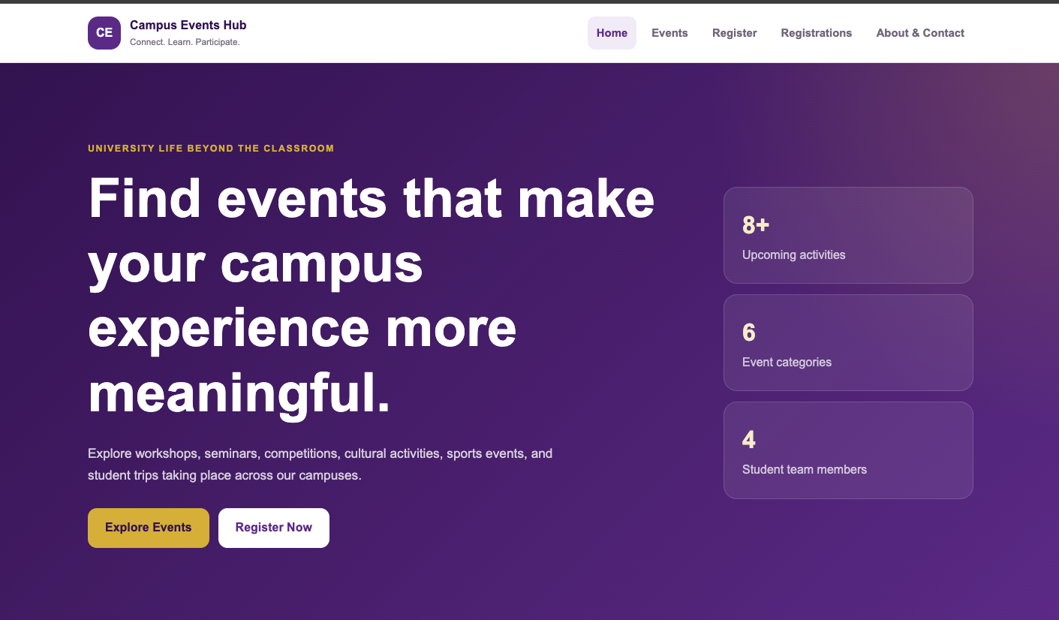
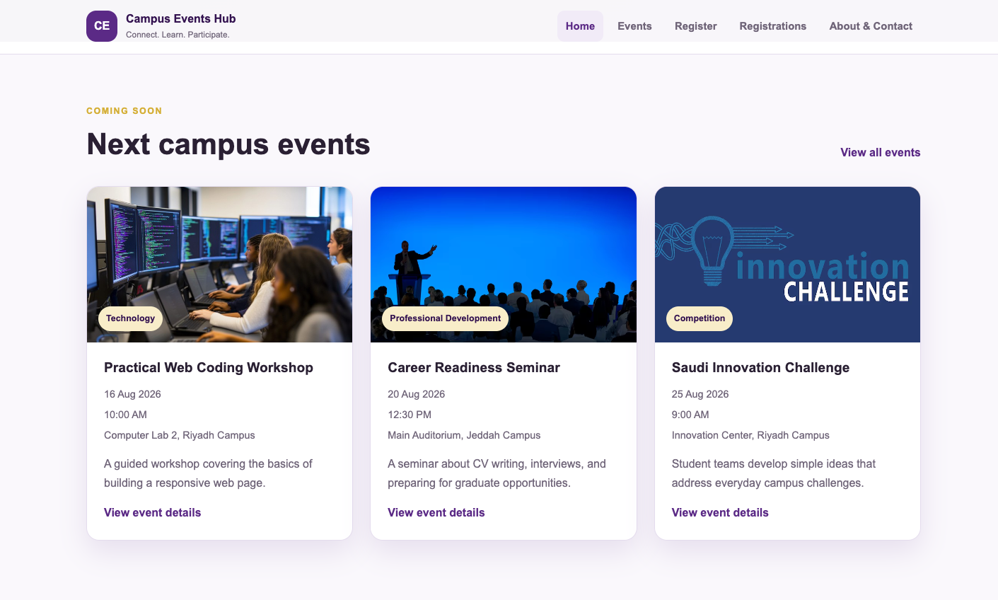
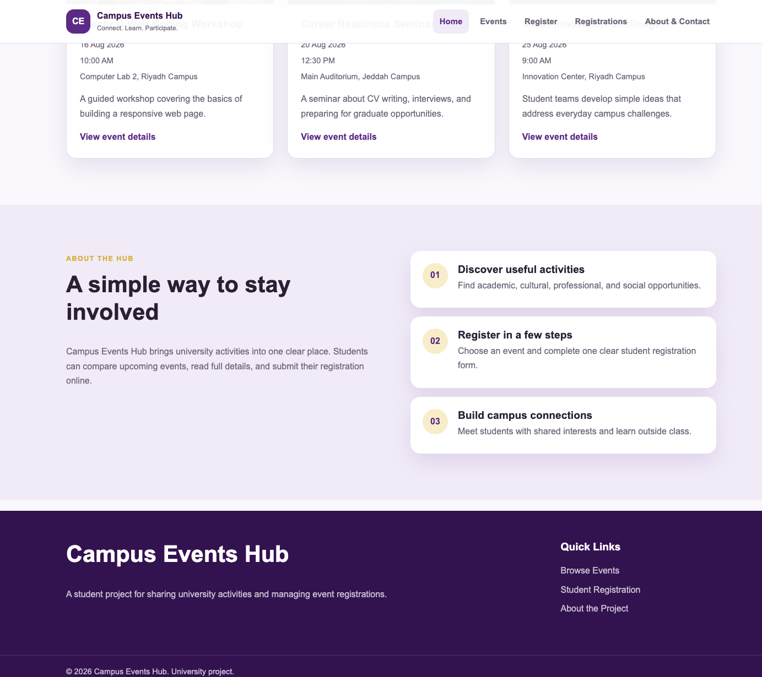

- Events page
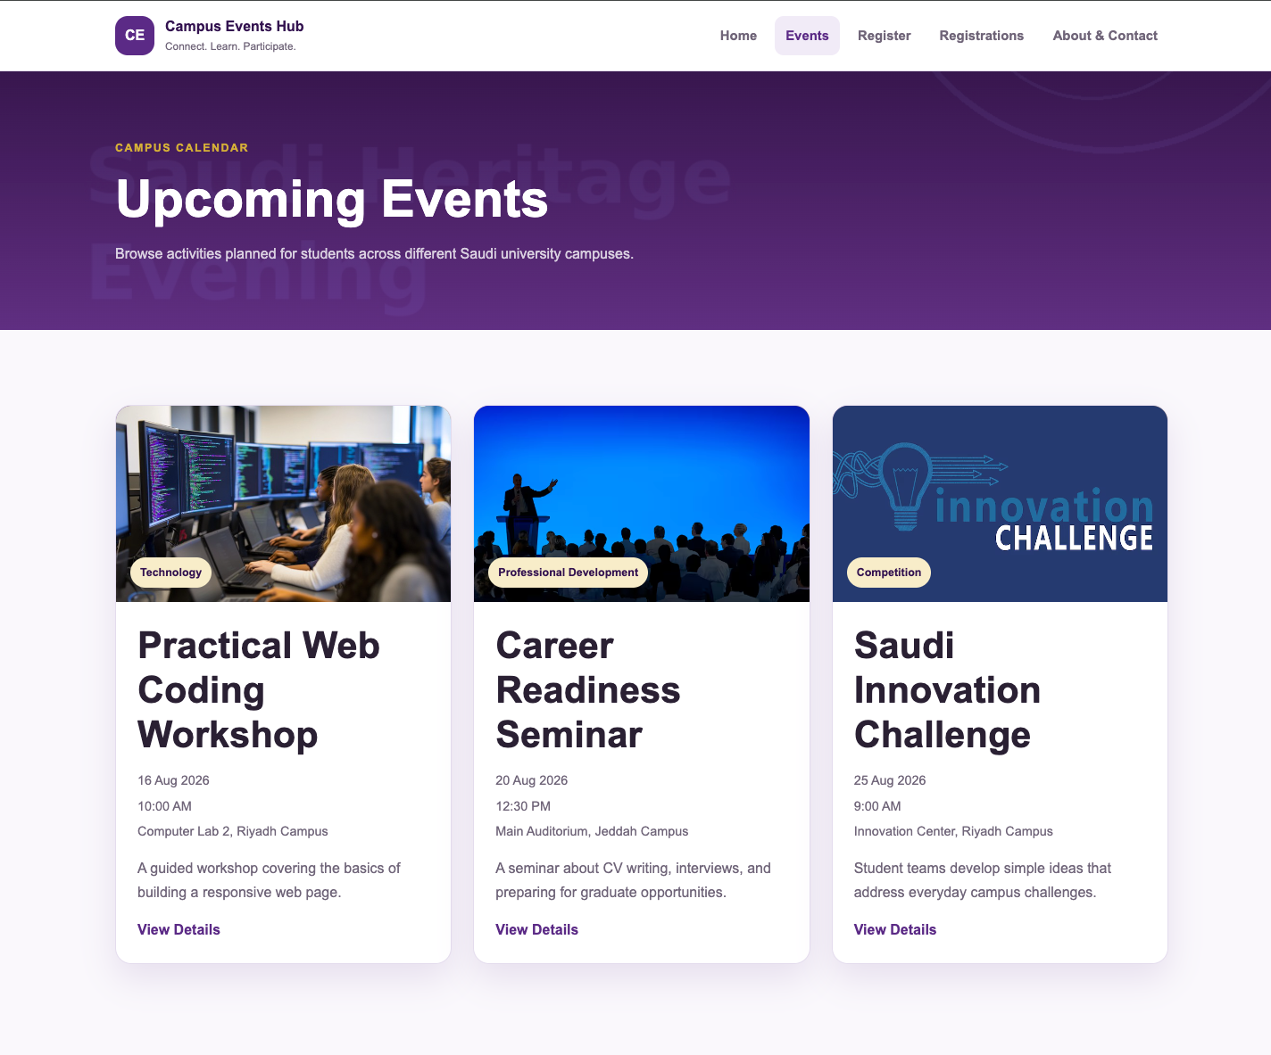

- Event details page
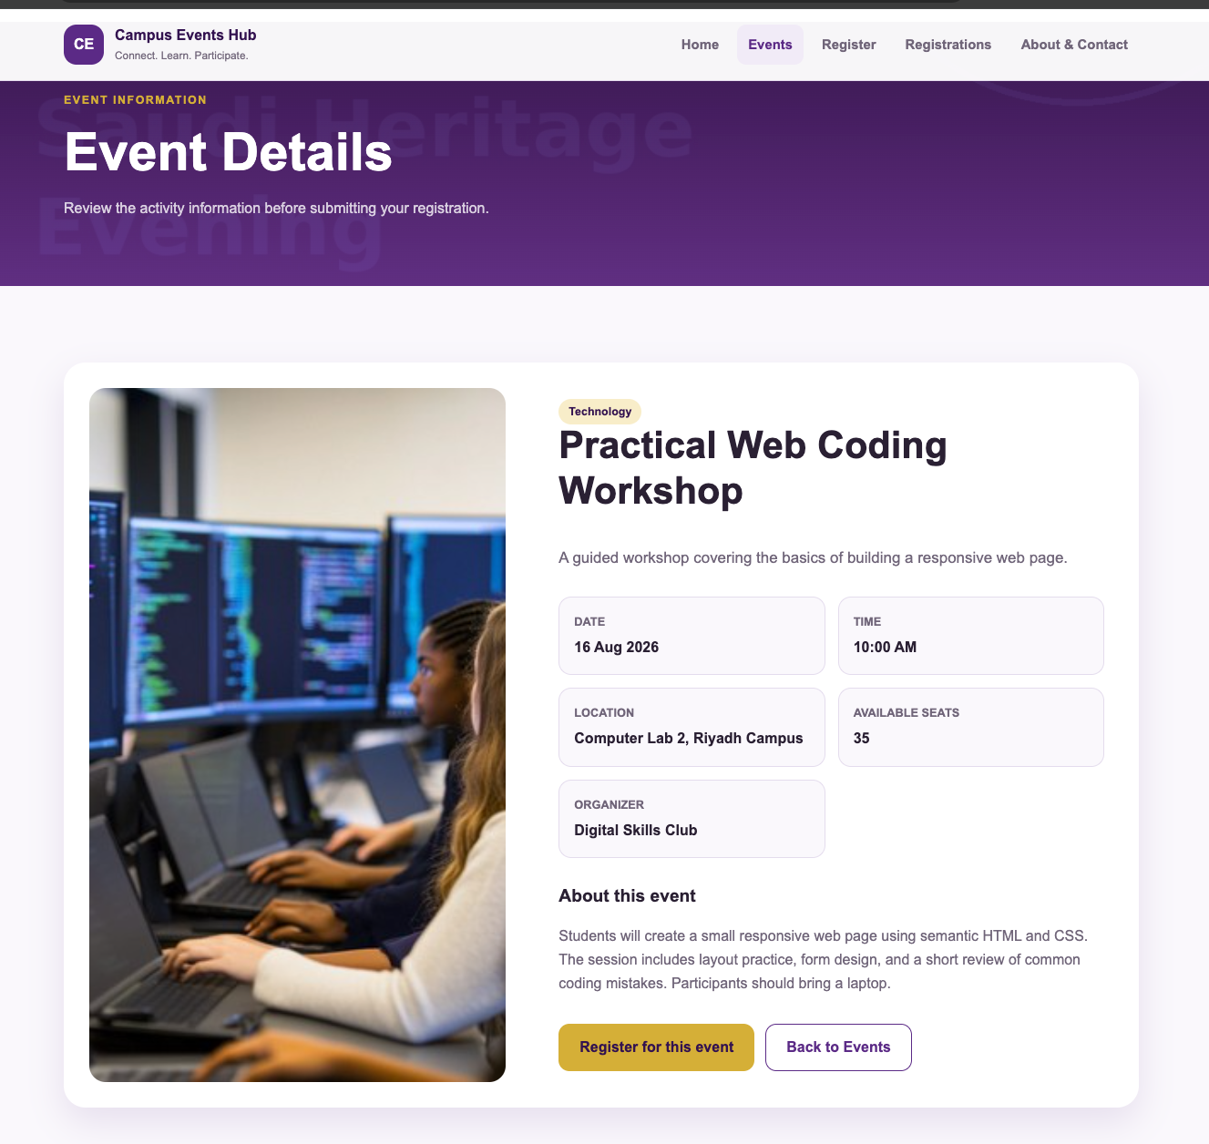

- Registration page
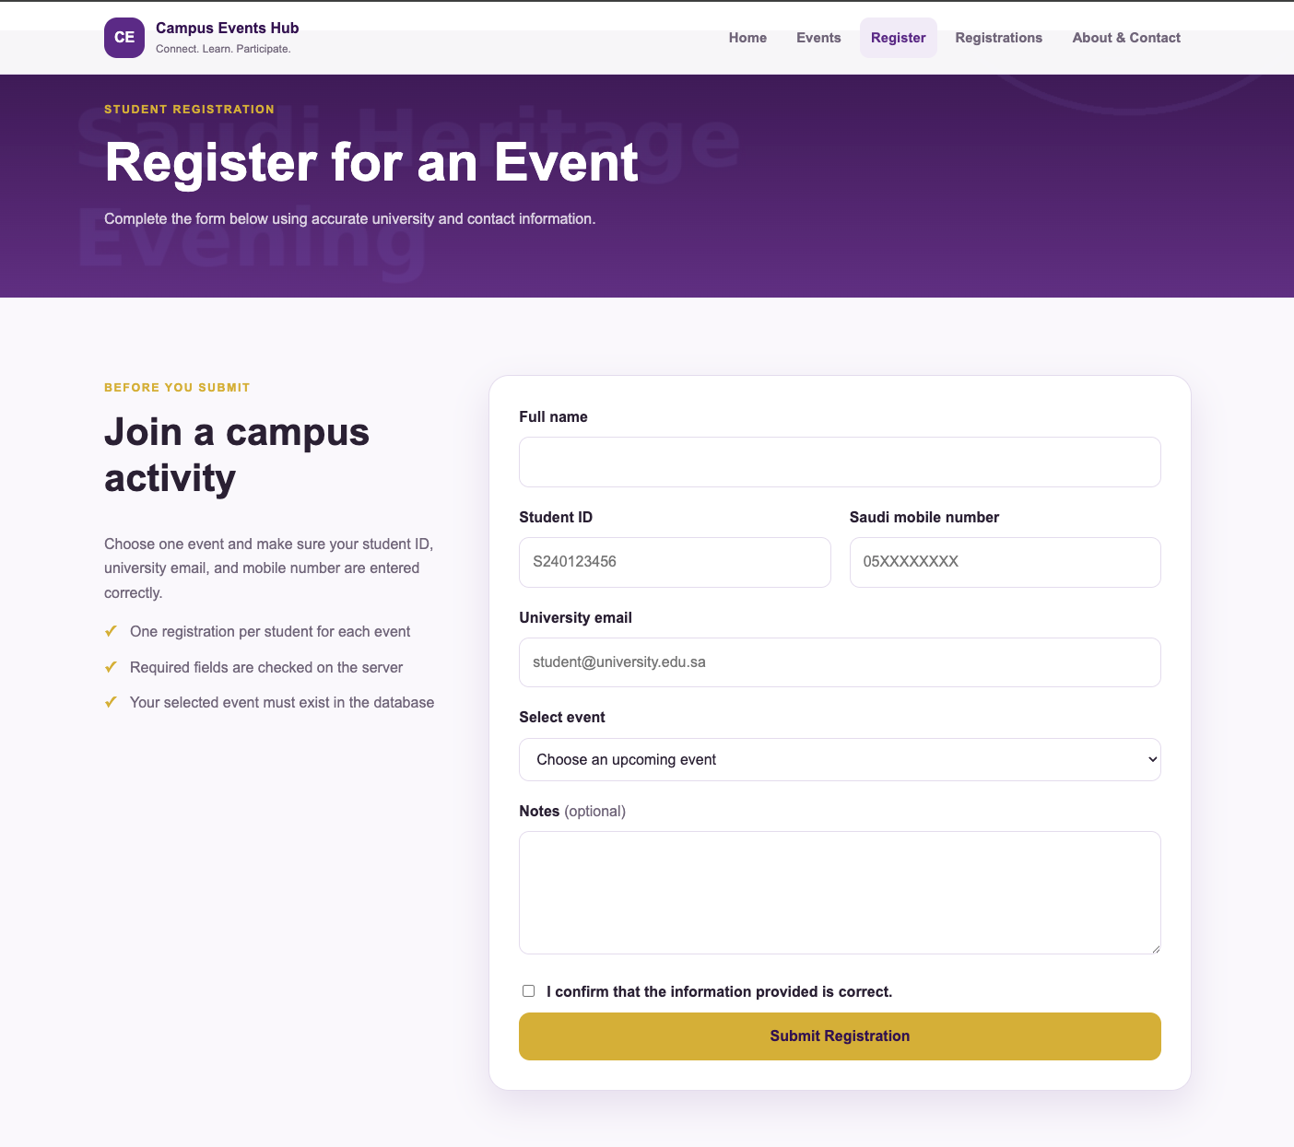

- Registrations list page
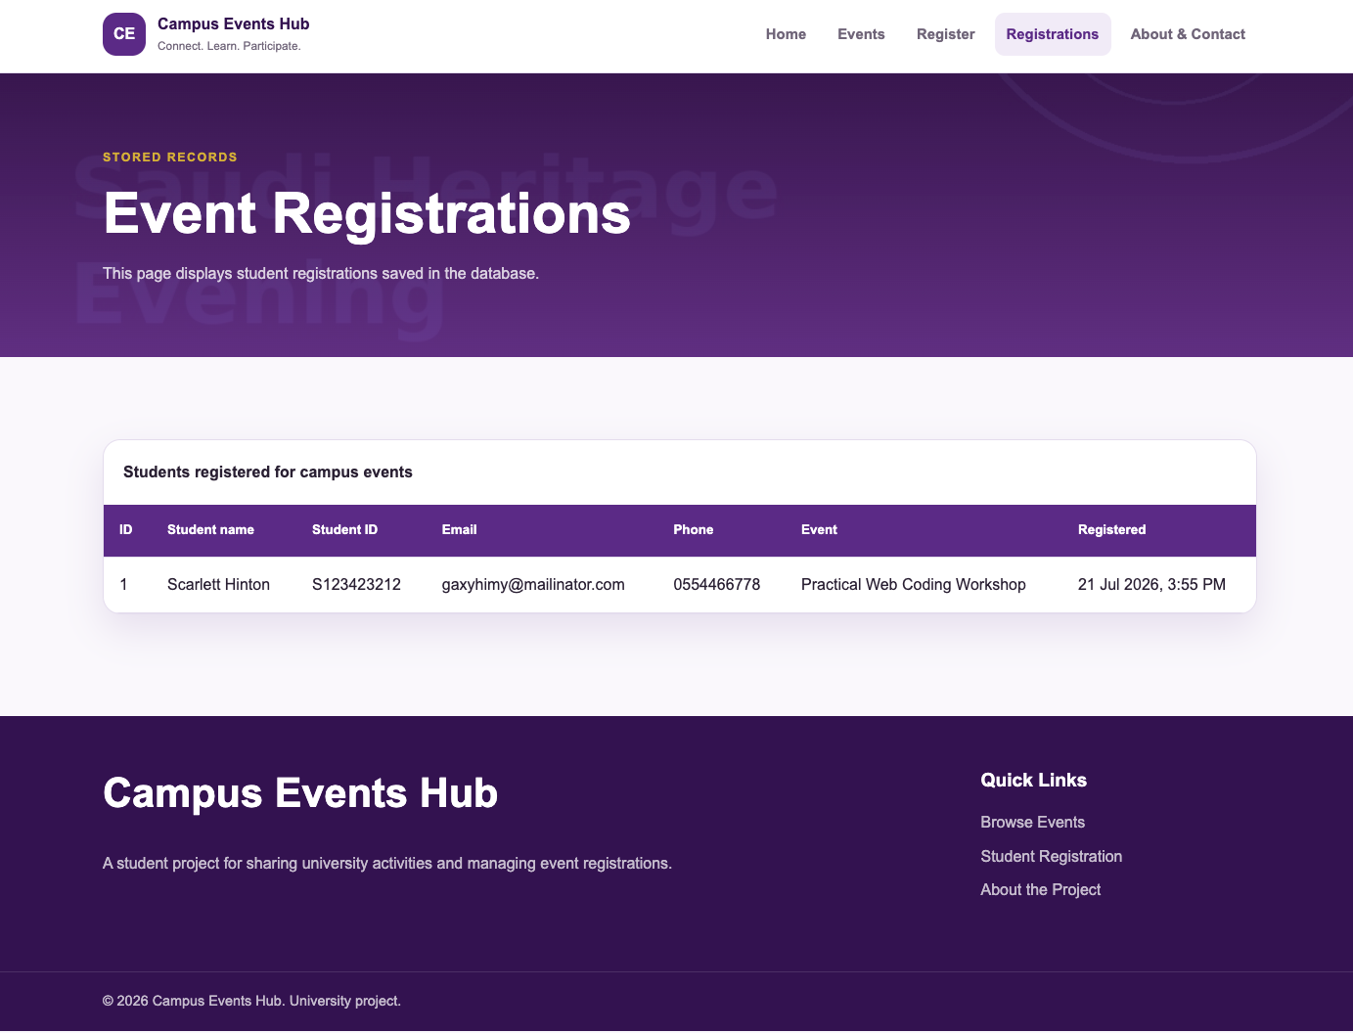

- About / Contact page

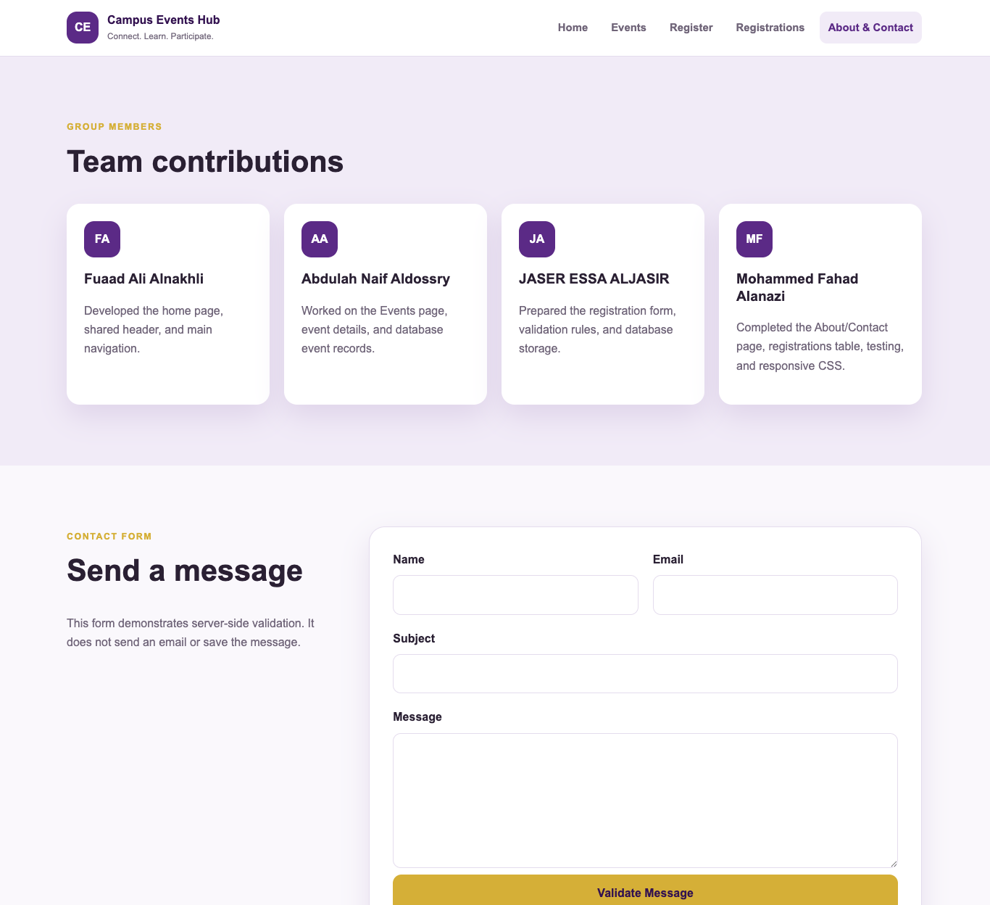

Website Code
- Home page

<?php
require_once 'includes/db.php';
require_once 'includes/functions.php';

$pageTitle = 'Home';

$sql = "SELECT id, title, category, event_date, event_time, location,
short_description, image
FROM events
WHERE event_date >= CURDATE()
ORDER BY event_date ASC, event_time ASC
LIMIT 3";

$result = mysqli_query($conn, $sql);

require 'includes/header.php';
?>

<section class="hero">
<div class="container hero-grid">
<div class="hero-content">
<span class="eyebrow">University life beyond the classroom</span>
<h1>Find events that make your campus experience more meaningful.</h1>
<p>
Explore workshops, seminars, competitions, cultural activities,
sports events, and student trips taking place across our campuses.
</p>
<div class="hero-actions">
<a class="button button-primary" href="events.php">Explore Events</a>
<a class="button button-light" href="register.php">Register Now</a>
</div>
</div>

<aside class="hero-panel" aria-label="Website highlights">
<div class="stat-card">
<strong>8+</strong>
<span>Upcoming activities</span>
</div>
<div class="stat-card">
<strong>6</strong>
<span>Event categories</span>
</div>
<div class="stat-card">
<strong>4</strong>
<span>Student team members</span>
</div>
</aside>
</div>
</section>

<section class="section">
<div class="container">
<div class="section-heading">
<div>
<span class="eyebrow">Coming soon</span>
<h2>Next campus events</h2>
</div>
<a class="text-link" href="events.php">View all events</a>
</div>

<div class="card-grid">
<?php if ($result && mysqli_num_rows($result) > 0): ?>
<?php while ($event = mysqli_fetch_assoc($result)): ?>
<article class="event-card">
<div class="event-image">
<img src="assets/images/<?php echo e($event['image']); ?>"
alt="<?php echo e($event['title']); ?>">
<span class="category-badge"><?php echo e($event['category']); ?></span>
</div>

<div class="event-body">
<h3><?php echo e($event['title']); ?></h3>
<ul class="event-meta">
<li><?php echo e(format_event_date($event['event_date'])); ?></li>
<li><?php echo e(format_event_time($event['event_time'])); ?></li>
<li><?php echo e($event['location']); ?></li>
</ul>
<p><?php echo e($event['short_description']); ?></p>
<a class="card-link" href="event.php?id=<?php echo (int) $event['id']; ?>">
View event details
</a>
</div>
</article>
<?php endwhile; ?>
<?php else: ?>
<div class="empty-state">
<h3>No upcoming events</h3>
<p>New activities will be added soon.</p>
</div>
<?php endif; ?>
</div>
</div>
</section>

<section class="section section-soft">
<div class="container split-section">
<div>
<span class="eyebrow">About the hub</span>
<h2>A simple way to stay involved</h2>
<p>
Campus Events Hub brings university activities into one clear place.
Students can compare upcoming events, read full details, and submit
their registration online.
</p>
</div>

<div class="feature-list">
<article>
<span>01</span>
<div>
<h3>Discover useful activities</h3>
<p>Find academic, cultural, professional, and social opportunities.</p>
</div>
</article>

<article>
<span>02</span>
<div>
<h3>Register in a few steps</h3>
<p>Choose an event and complete one clear student registration form.</p>
</div>
</article>

<article>
<span>03</span>
<div>
<h3>Build campus connections</h3>
<p>Meet students with shared interests and learn outside class.</p>
</div>
</article>
</div>
</div>
</section>
<?php require 'includes/footer.php'; ?>

- Events page

<?php
require_once 'includes/db.php';
require_once 'includes/functions.php';

$pageTitle = 'Events';

$sql = "SELECT id, title, category, event_date, event_time, location,
short_description, image
FROM events
ORDER BY event_date ASC, event_time ASC";

$result = mysqli_query($conn, $sql);

require 'includes/header.php';
?>

<section class="page-banner">
<div class="container">
<span class="eyebrow">Campus calendar</span>
<h1>Upcoming Events</h1>
<p>Browse activities planned for students across different Saudi university campuses.</p>
</div>
</section>

<section class="section">
<div class="container">
<div class="card-grid">
<?php if ($result && mysqli_num_rows($result) > 0): ?>
<?php while ($event = mysqli_fetch_assoc($result)): ?>
<article class="event-card">
<div class="event-image">
<img src="assets/images/<?php echo e($event['image']); ?>"
alt="<?php echo e($event['title']); ?>">
<span class="category-badge"><?php echo e($event['category']); ?></span>
</div>

<div class="event-body">
<h2><?php echo e($event['title']); ?></h2>
<ul class="event-meta">
<li><?php echo e(format_event_date($event['event_date'])); ?></li>
<li><?php echo e(format_event_time($event['event_time'])); ?></li>
<li><?php echo e($event['location']); ?></li>
</ul>
<p><?php echo e($event['short_description']); ?></p>
<a class="card-link" href="event.php?id=<?php echo (int) $event['id']; ?>">
View Details
</a>
</div>
</article>
<?php endwhile; ?>
<?php else: ?>
<div class="empty-state">
<h2>No events are available</h2>
<p>Please return later to check the updated campus schedule.</p>
</div>
<?php endif; ?>
</div>
</div>
</section>

<?php require 'includes/footer.php'; ?>

- Event details page

<?php
require_once 'includes/db.php';
require_once 'includes/functions.php';

$pageTitle = 'Event Details';
$event = null;
$errorMessage = '';

$eventId = filter_input(INPUT_GET, 'id', FILTER_VALIDATE_INT);

if (!$eventId || $eventId < 1) {
$errorMessage = 'The event ID is missing or invalid.';
} else {
$stmt = mysqli_prepare(
$conn,
"SELECT id, title, category, event_date, event_time, location,
short_description, full_description, image,
available_seats, organizer
FROM events
WHERE id = ?"
);

mysqli_stmt_bind_param($stmt, 'i', $eventId);
mysqli_stmt_execute($stmt);
$result = mysqli_stmt_get_result($stmt);
$event = mysqli_fetch_assoc($result);

if (!$event) {
$errorMessage = 'The selected event could not be found.';
}

mysqli_stmt_close($stmt);
}

require 'includes/header.php';
?>

<section class="page-banner">
<div class="container">
<span class="eyebrow">Event information</span>
<h1>Event Details</h1>
<p>Review the activity information before submitting your registration.</p>
</div>
</section>

<section class="section">
<div class="container">
<?php if ($errorMessage): ?>
<div class="alert alert-error">
<h2>Unable to open this event</h2>
<p><?php echo e($errorMessage); ?></p>
<a class="button button-primary" href="events.php">Return to Events</a>
</div>
<?php else: ?>
<article class="detail-layout">
<div class="detail-image">
<img src="assets/images/<?php echo e($event['image']); ?>"
alt="<?php echo e($event['title']); ?>">
</div>

<div class="detail-content">
<span class="category-badge static-badge"><?php echo e($event['category']); ?></span>
<h2><?php echo e($event['title']); ?></h2>
<p class="lead"><?php echo e($event['short_description']); ?></p>

<dl class="detail-list">
<div>
<dt>Date</dt>
<dd><?php echo e(format_event_date($event['event_date'])); ?></dd>
</div>
<div>
<dt>Time</dt>
<dd><?php echo e(format_event_time($event['event_time'])); ?></dd>
</div>
<div>
<dt>Location</dt>
<dd><?php echo e($event['location']); ?></dd>
</div>
<div>
<dt>Available seats</dt>
<dd><?php echo (int) $event['available_seats']; ?></dd>
</div>
<div>
<dt>Organizer</dt>
<dd><?php echo e($event['organizer']); ?></dd>
</div>
</dl>

<div class="detail-description">
<h3>About this event</h3>
<p><?php echo nl2br(e($event['full_description'])); ?></p>
</div>

<div class="detail-actions">
<a class="button button-primary"
href="register.php?event_id=<?php echo (int) $event['id']; ?>">
Register for this event
</a>
<a class="button button-outline" href="events.php">Back to Events</a>
</div>
</div>
</article>
<?php endif; ?>
</div>
</section>

<?php require 'includes/footer.php'; ?>

- Registration page

<?php
require_once 'includes/db.php';
require_once 'includes/functions.php';

$pageTitle = 'Register';

$errors = [];
$successMessage = '';

$fullName = '';
$studentId = '';
$email = '';
$phone = '';
$selectedEvent = '';
$notes = '';
$agreement = '';

if ($_SERVER['REQUEST_METHOD'] !== 'POST') {
$urlEventId = filter_input(INPUT_GET, 'event_id', FILTER_VALIDATE_INT);
if ($urlEventId && $urlEventId > 0) {
$selectedEvent = (string) $urlEventId;
}
}

if ($_SERVER['REQUEST_METHOD'] === 'POST') {
$fullName = trim($_POST['full_name'] ?? '');
$studentId = trim($_POST['student_id'] ?? '');
$email = trim($_POST['email'] ?? '');
$phone = trim($_POST['phone'] ?? '');
$selectedEvent = trim($_POST['event_id'] ?? '');
$notes = trim($_POST['notes'] ?? '');
$agreement = $_POST['agreement'] ?? '';

if ($fullName === '') {
$errors['full_name'] = 'Please enter your full name.';
} elseif (strlen($fullName) < 4) {
$errors['full_name'] = 'The full name must contain at least 4 characters.';
}

if ($studentId === '') {
$errors['student_id'] = 'Please enter your student ID.';
} elseif (!preg_match('/^S?\d{9}$/i', $studentId)) {
$errors['student_id'] = 'Use 9 digits, with an optional S at the beginning.';
}

if ($email === '') {
$errors['email'] = 'Please enter your email address.';
} elseif (!filter_var($email, FILTER_VALIDATE_EMAIL)) {
$errors['email'] = 'Please enter a valid email address.';
}

if ($phone === '') {
$errors['phone'] = 'Please enter your mobile number.';
} elseif (!preg_match('/^05\d{8}$/', $phone)) {
$errors['phone'] = 'Use a Saudi mobile number in the format 05XXXXXXXX.';
}

if (!ctype_digit($selectedEvent) || (int) $selectedEvent < 1) {
$errors['event_id'] = 'Please select a valid event.';
} else {
$eventCheck = mysqli_prepare($conn, "SELECT id FROM events WHERE id = ?");
$eventNumber = (int) $selectedEvent;
mysqli_stmt_bind_param($eventCheck, 'i', $eventNumber);
mysqli_stmt_execute($eventCheck);
$eventResult = mysqli_stmt_get_result($eventCheck);

if (mysqli_num_rows($eventResult) !== 1) {
$errors['event_id'] = 'The selected event does not exist.';
}

mysqli_stmt_close($eventCheck);
}

if (strlen($notes) > 500) {
$errors['notes'] = 'Notes must not exceed 500 characters.';
}

if ($agreement !== 'yes') {
$errors['agreement'] = 'You must confirm that the information is correct.';
}

if (!$errors) {
$eventNumber = (int) $selectedEvent;

$duplicateStmt = mysqli_prepare(
$conn,
"SELECT id FROM registrations WHERE event_id = ? AND student_id = ?"
);
mysqli_stmt_bind_param($duplicateStmt, 'is', $eventNumber, $studentId);
mysqli_stmt_execute($duplicateStmt);
$duplicateResult = mysqli_stmt_get_result($duplicateStmt);

if (mysqli_num_rows($duplicateResult) > 0) {
$errors['general'] = 'This student ID is already registered for the selected event.';
}

mysqli_stmt_close($duplicateStmt);
}

if (!$errors) {
$insertStmt = mysqli_prepare(
$conn,
"INSERT INTO registrations
(event_id, full_name, student_id, email, phone, notes)
VALUES (?, ?, ?, ?, ?, ?)"
);

mysqli_stmt_bind_param(
$insertStmt,
'isssss',
$eventNumber,
$fullName,
$studentId,
$email,
$phone,
$notes
);

if (mysqli_stmt_execute($insertStmt)) {
$successMessage = 'Your registration was submitted successfully.';
$fullName = '';
$studentId = '';
$email = '';
$phone = '';
$selectedEvent = '';
$notes = '';
$agreement = '';
} else {
$errors['general'] = 'The registration could not be saved. Please try again.';
}

mysqli_stmt_close($insertStmt);
}
}

$eventsResult = mysqli_query(
$conn,
"SELECT id, title, event_date
FROM events
WHERE event_date >= CURDATE()
ORDER BY event_date ASC"
);

require 'includes/header.php';
?>

<section class="page-banner">
<div class="container">
<span class="eyebrow">Student registration</span>
<h1>Register for an Event</h1>
<p>Complete the form below using accurate university and contact information.</p>
</div>
</section>

<section class="section">
<div class="container form-layout">
<aside class="form-intro">
<span class="eyebrow">Before you submit</span>
<h2>Join a campus activity</h2>
<p>
Choose one event and make sure your student ID, university email,
and mobile number are entered correctly.
</p>
<ul class="check-list">
<li>One registration per student for each event</li>
<li>Required fields are checked on the server</li>
<li>Your selected event must exist in the database</li>
</ul>
</aside>

<div class="form-card">
<?php if ($successMessage): ?>
<div class="alert alert-success">
<strong>Registration complete</strong>
<p><?php echo e($successMessage); ?></p>
</div>
<?php endif; ?>

<?php if (isset($errors['general'])): ?>
<div class="alert alert-error">
<strong>Registration not completed</strong>
<p><?php echo e($errors['general']); ?></p>
</div>
<?php endif; ?>

<form method="post" action="register.php" novalidate>
<div class="form-grid">
<div class="form-group full-width">
<label for="full_name">Full name</label>
<input type="text" id="full_name" name="full_name"
value="<?php echo e($fullName); ?>"
autocomplete="name" required>
<?php if (isset($errors['full_name'])): ?>
<small class="field-error"><?php echo e($errors['full_name']); ?></small>
<?php endif; ?>
</div>

<div class="form-group">
<label for="student_id">Student ID</label>
<input type="text" id="student_id" name="student_id"
value="<?php echo e($studentId); ?>"
placeholder="S240123456" required>
<?php if (isset($errors['student_id'])): ?>
<small class="field-error"><?php echo e($errors['student_id']); ?></small>
<?php endif; ?>
</div>

<div class="form-group">
<label for="phone">Saudi mobile number</label>
<input type="tel" id="phone" name="phone"
value="<?php echo e($phone); ?>"
placeholder="05XXXXXXXX" required>
<?php if (isset($errors['phone'])): ?>
<small class="field-error"><?php echo e($errors['phone']); ?></small>
<?php endif; ?>
</div>

<div class="form-group full-width">
<label for="email">University email</label>
<input type="email" id="email" name="email"
value="<?php echo e($email); ?>"
placeholder="student@university.edu.sa"
autocomplete="email" required>
<?php if (isset($errors['email'])): ?>
<small class="field-error"><?php echo e($errors['email']); ?></small>
<?php endif; ?>
</div>

<div class="form-group full-width">
<label for="event_id">Select event</label>
<select id="event_id" name="event_id" required>
<option value="">Choose an upcoming event</option>
<?php if ($eventsResult): ?>
<?php while ($eventOption = mysqli_fetch_assoc($eventsResult)): ?>
<option value="<?php echo (int) $eventOption['id']; ?>"
<?php echo (string) $eventOption['id'] === (string) $selectedEvent ? 'selected' : ''; ?>>
<?php echo e($eventOption['title']); ?>
- <?php echo e(format_event_date($eventOption['event_date'])); ?>
</option>
<?php endwhile; ?>
<?php endif; ?>
</select>
<?php if (isset($errors['event_id'])): ?>
<small class="field-error"><?php echo e($errors['event_id']); ?></small>
<?php endif; ?>
</div>

<div class="form-group full-width">
<label for="notes">Notes <span class="optional">(optional)</span></label>
<textarea id="notes" name="notes" rows="4"
maxlength="500"><?php echo e($notes); ?></textarea>
<?php if (isset($errors['notes'])): ?>
<small class="field-error"><?php echo e($errors['notes']); ?></small>
<?php endif; ?>
</div>

<div class="form-group full-width checkbox-group">
<label>
<input type="checkbox" name="agreement" value="yes"
<?php echo $agreement === 'yes' ? 'checked' : ''; ?>>
I confirm that the information provided is correct.
</label>
<?php if (isset($errors['agreement'])): ?>
<small class="field-error"><?php echo e($errors['agreement']); ?></small>
<?php endif; ?>
</div>
</div>

<button class="button button-primary button-full" type="submit">
Submit Registration
</button>
</form>
</div>
</div>
</section>

<?php require 'includes/footer.php'; ?>

- Registrations list page

<?php
require_once 'includes/db.php';
require_once 'includes/functions.php';

$pageTitle = 'Registrations';

$sql = "SELECT r.id, r.full_name, r.student_id, r.email, r.phone,
r.registered_at, e.title AS event_title
FROM registrations r
INNER JOIN events e ON r.event_id = e.id
ORDER BY r.registered_at DESC";

$result = mysqli_query($conn, $sql);

require 'includes/header.php';
?>

<section class="page-banner">
<div class="container">
<span class="eyebrow">Stored records</span>
<h1>Event Registrations</h1>
<p>This page displays student registrations saved in the database.</p>
</div>
</section>

<section class="section">
<div class="container">
<?php if ($result && mysqli_num_rows($result) > 0): ?>
<div class="table-wrap">
<table>
<caption>Students registered for campus events</caption>
<thead>
<tr>
<th>ID</th>
<th>Student name</th>
<th>Student ID</th>
<th>Email</th>
<th>Phone</th>
<th>Event</th>
<th>Registered</th>
</tr>
</thead>
<tbody>
<?php while ($registration = mysqli_fetch_assoc($result)): ?>
<tr>
<td data-label="ID"><?php echo (int) $registration['id']; ?></td>
<td data-label="Student name"><?php echo e($registration['full_name']); ?></td>
<td data-label="Student ID"><?php echo e($registration['student_id']); ?></td>
<td data-label="Email"><?php echo e($registration['email']); ?></td>
<td data-label="Phone"><?php echo e($registration['phone']); ?></td>
<td data-label="Event"><?php echo e($registration['event_title']); ?></td>
<td data-label="Registered">
<?php echo e(date('d M Y, g:i A', strtotime($registration['registered_at']))); ?>
</td>
</tr>
<?php endwhile; ?>
</tbody>
</table>
</div>
<?php else: ?>
<div class="empty-state">
<h2>No registrations have been submitted</h2>
<p>Student records will appear here after the first valid registration.</p>
<a class="button button-primary" href="register.php">Open Registration Form</a>
</div>
<?php endif; ?>
</div>
</section>

<?php require 'includes/footer.php'; ?>

- About / Contact page

<?php
require_once 'includes/functions.php';

$pageTitle = 'About and Contact';

$errors = [];
$successMessage = '';

$name = '';
$email = '';
$subject = '';
$message = '';

if ($_SERVER['REQUEST_METHOD'] === 'POST') {
$name = trim($_POST['name'] ?? '');
$email = trim($_POST['email'] ?? '');
$subject = trim($_POST['subject'] ?? '');
$message = trim($_POST['message'] ?? '');

if ($name === '') {
$errors['name'] = 'Please enter your name.';
} elseif (strlen($name) < 3) {
$errors['name'] = 'The name must contain at least 3 characters.';
}

if ($email === '') {
$errors['email'] = 'Please enter your email address.';
} elseif (!filter_var($email, FILTER_VALIDATE_EMAIL)) {
$errors['email'] = 'Please enter a valid email address.';
}

if ($subject === '') {
$errors['subject'] = 'Please enter a subject.';
} elseif (strlen($subject) < 4) {
$errors['subject'] = 'The subject must contain at least 4 characters.';
}

if ($message === '') {
$errors['message'] = 'Please enter your message.';
} elseif (strlen($message) < 10) {
$errors['message'] = 'The message must contain at least 10 characters.';
}

if (!$errors) {
$successMessage = 'Thank you. Your message passed validation successfully.';
$name = '';
$email = '';
$subject = '';
$message = '';
}
}

require 'includes/header.php';
?>

<section class="page-banner">
<div class="container">
<span class="eyebrow">Project and team</span>
<h1>About Campus Events Hub</h1>
<p>Learn about the project purpose, student team, and development responsibilities.</p>
</div>
</section>

<section class="section">
<div class="container split-section">
<div>
<span class="eyebrow">Our background</span>
<h2>Supporting student participation</h2>
<p>
Campus Events Hub is a fictional university service created to make
campus activities easier to find and join. It brings event information
and registration into one simple website.
</p>

<h3>Mission</h3>
<p>
Our mission is to help students discover useful academic, cultural,
professional, and social opportunities across university campuses.
</p>

<h3>Objectives</h3>
<ul class="check-list">
<li>Present upcoming events in a clear and consistent format.</li>
<li>Allow students to register using a validated online form.</li>
<li>Store and display registrations using a simple database.</li>
<li>Apply core HTML, CSS, PHP, and MySQL skills in one project.</li>
</ul>
</div>

<aside class="project-card">
<span class="eyebrow">Project period</span>
<h2>15 July–9 August 2026</h2>
<p>
The work was divided into planning, interface development,
PHP implementation, database connection, validation, and testing.
</p>
</aside>
</div>
</section>

<section class="section section-soft">
<div class="container">
<div class="section-heading">
<div>
<span class="eyebrow">Group members</span>
<h2>Team contributions</h2>
</div>
</div>

<div class="team-grid">
<article class="team-card">
<span>FA</span>
<h3>Fuaad Ali Alnakhli</h3>
<p>Developed the home page, shared header, and main navigation.</p>
</article>

<article class="team-card">
<span>AA</span>
<h3>Abdulah Naif Aldossry</h3>
<p>Worked on the Events page, event details, and database event records.</p>
</article>

<article class="team-card">
<span>JA</span>
<h3>JASER ESSA ALJASIR</h3>
<p>Prepared the registration form, validation rules, and database storage.</p>
</article>

<article class="team-card">
<span>MF</span>
<h3>Mohammed Fahad Alanazi</h3>
<p>Completed the About/Contact page, registrations table, testing, and responsive CSS.</p>
</article>
</div>
</div>
</section>

<section class="section">
<div class="container form-layout">
<aside class="form-intro">
<span class="eyebrow">Contact form</span>
<h2>Send a message</h2>
<p>
This form demonstrates server-side validation. It does not send
an email or save the message.
</p>
</aside>

<div class="form-card">
<?php if ($successMessage): ?>
<div class="alert alert-success">
<strong>Message accepted</strong>
<p><?php echo e($successMessage); ?></p>
</div>
<?php endif; ?>

<form method="post" action="about.php#contact" id="contact" novalidate>
<div class="form-grid">
<div class="form-group">
<label for="name">Name</label>
<input type="text" id="name" name="name"
value="<?php echo e($name); ?>"
autocomplete="name" required>
<?php if (isset($errors['name'])): ?>
<small class="field-error"><?php echo e($errors['name']); ?></small>
<?php endif; ?>
</div>

<div class="form-group">
<label for="contact_email">Email</label>
<input type="email" id="contact_email" name="email"
value="<?php echo e($email); ?>"
autocomplete="email" required>
<?php if (isset($errors['email'])): ?>
<small class="field-error"><?php echo e($errors['email']); ?></small>
<?php endif; ?>
</div>

<div class="form-group full-width">
<label for="subject">Subject</label>
<input type="text" id="subject" name="subject"
value="<?php echo e($subject); ?>" required>
<?php if (isset($errors['subject'])): ?>
<small class="field-error"><?php echo e($errors['subject']); ?></small>
<?php endif; ?>
</div>

<div class="form-group full-width">
<label for="message">Message</label>
<textarea id="message" name="message" rows="6"
required><?php echo e($message); ?></textarea>
<?php if (isset($errors['message'])): ?>
<small class="field-error"><?php echo e($errors['message']); ?></small>
<?php endif; ?>
</div>
</div>

<button class="button button-primary button-full" type="submit">
Validate Message
</button>
</form>
</div>
</div>
</section>

<?php require 'includes/footer.php'; ?>
Reflection
One of the main challenges we faced during the project was making the registration form work correctly with the database. At first, the form could collect student information, but we needed to make sure that the selected event was valid and that the same student could not register twice for the same event. We identified the problem while testing different cases, such as submitting an invalid event ID through the URL and repeating a registration using the same student ID. To solve this, we added server-side validation, checked that the selected event existed in the events table, and created a unique database constraint using the event ID and student ID. We also used MySQLi prepared statements when checking and inserting registration records. This helped us improve both the reliability and security of the form.
We chose to store events and registrations in a MySQL database instead of using a CSV file. A CSV file would have been easier to create at the beginning, but it would have made searching, joining, validating, and preventing duplicate records more difficult. The database allowed us to connect each registration to a specific event through a foreign key and display the registration list using an SQL join. The tradeoff was that the database required more setup, including table creation, connection settings, and SQL queries. However, we believed this approach was more suitable because the project required dynamic data handling and gave us better control over stored records.
For the page layout, we used CSS Grid and Flexbox instead of fixed-width layouts. This made the event cards, forms, navigation, and team sections adapt more easily to different screen sizes. We also used media queries to improve the table and navigation on mobile devices. Although responsive design required extra testing, it produced a more usable and consistent website.
We used ChatGPT during the project for brainstorming page structure, reviewing validation logic, identifying possible PHP errors, and improving the clarity of some written content. We did not copy the suggestions without checking them. We compared the generated code with our database fields, tested the forms manually, corrected naming differences, and simplified any code that was more complex than necessary.
If we repeated the project with more time, we would add an administrator page for managing events, automatic seat-count updates, and email confirmation after registration. We would also conduct more testing with different browsers, screen sizes, and invalid user inputs.

